Orthogonal Frequency Division Multiplexing
The OFDM example generates baseband complex waveform based on OFDM modulation. This is a very general tool that simulates most of OFDM systems currently in use or under development. For proper generation of the OFDM signal a number of parameters need to be configured. For example, the final payload in the OFDM Frame may consist of a number of OFDM Symbols and each OFDM symbol may use different modulation schemes. The example vi facilitates configuration of OFDM parameters in a series of steps. For example, different data sources may be configured by executing STEP 1, as shown in Fig. 1.

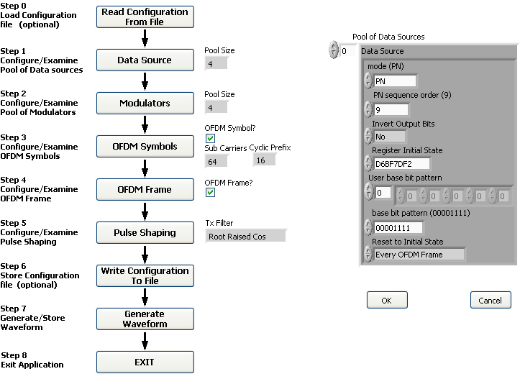

Figure 1: Front Panel of proposed example VI

After completing the Steps 0 through 6, the OFDM signal is generated which can be stored in Datalog file for future reference.

Background
OFDM spreads the data to be transmitted over a large number of carriers -- typically in the range of 50 to 1000, but sometimes in thousands, for example, DVB-T has options for using either 1705 or 6817 carriers. The data rate to be conveyed by each of these carriers is correspondingly reduced. It follows that the symbol length is in turn extended. These modulation symbols on each of the carriers are arranged to occur simultaneously.
The carriers have common, precisely-chosen frequency spacing. This is the inverse of the duration, called the active symbol period, over which the receiver will examine the signal, performing the equivalent of an ‘integrate-and-dump’ demodulation. This choice of carrier spacing ensures orthogonality (the ‘O’ of OFDM) of the carriers -- the demodulator for one carrier does not ‘see’ the modulation of the others, so there is no crosstalk between carriers, even though there is no explicit filtering and their spectra overlap.
A further refinement adds the concept of a guard interval. Each modulation symbol is transmitted for a total symbol period which is longer than the active symbol period by a period called the guard interval. This means that the receiver will experience neither inter-symbol nor inter-carrier interference provided that any echoes present in the signal have a delay which does not exceed the guard interval. Naturally, the addition of the guard interval reduces the data capacity by an amount dependent on its length. The concept of a guard interval could in principle be applied to a single-carrier system, but the loss of data capacity would normally be prohibitive. With OFDM it is possible to protect against echoes with prolonged delay, simply by choosing a sufficient number of carriers that the guard interval need not form too great a fraction of the active symbol period. Both DAB and DVB-T have a guard interval which is no greater than 1/4 of the active symbol period, but can protect against echo delays of the order of 200 µs (depending on the mode chosen).
Fortunately the apparently very complex processes of modulating (and demodulating) hundreds of carriers simultaneously are equivalent to Discrete Fourier Transform operations, for which efficient Fast Fourier Transform (FFT) algorithms exist. Thus integrated circuit implementations of OFDM demodulators are feasible for affordable mass-produced receivers.

OFDM Generation
To generate OFDM successfully the relationship between all the carriers must be carefully controlled to maintain the orthogonality of the carriers. For this reason, OFDM is generated by firstly choosing the spectrum required, based on the input data, and modulation scheme used. Each carrier to be produced is assigned some data to transmit. The required amplitude and phase of the carrier is then calculated based on the modulation scheme (typically differential BPSK, QPSK, or QAM). The required spectrum is then converted back to its time domain signal using an Inverse Fourier Transform. In most applications, an Inverse Fast Fourier Transform (IFFT) is used. The IFFT performs the transformation very efficiently, and provides a simple way of ensuring the carrier signals produced are orthogonal. The Fast Fourier Transform (FFT) transforms a cyclic time domain signal into its equivalent frequency spectrum. This is done by finding the equivalent waveform, generated by a sum of orthogonal sinusoidal components. The amplitude and phase of the sinusoidal components represent the frequency spectrum of the time domain signal. The IFFT performs the reverse process, transforming a spectrum (amplitude and phase of each component) into a time domain signal. An IFFT converts a number of complex data points, of length that is a power of 2, into the time domain signal of the same number of points. Each data point in frequency spectrum used for an FFT or IFFT is called a bin.
The orthogonal carriers required for the OFDM signal can be easily generated by setting the amplitude and phase of each frequency bin, then performing the IFFT. Since each bin of an IFFT corresponds to the amplitude and phase of a set of orthogonal sinusoids, the reverse process guarantees that the carriers generated are orthogonal.

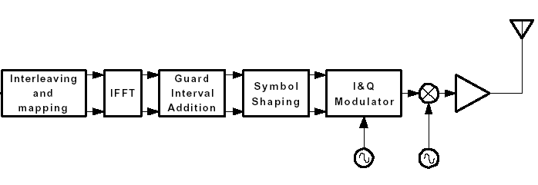

Figure 2: Basic OFDM transmitter.

Sideband Cancellation Filter Generation
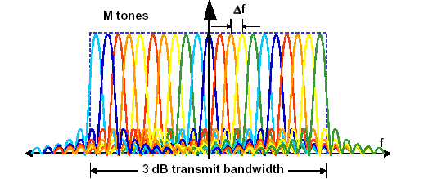
Figure 3: OFDM Spectrum.

Mod_OFDM_Application.vi
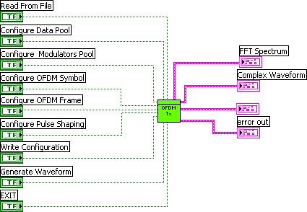

Inputs
- Read Configuration from File: Click on the “Read Configuration from File” control to load an .ofm file in to the example VI. The VI executed during this step opens a file dialog box, where the user selects a pre-configured saved file (Step 0).

- Configure Data Source Pool: Click on the “Data Sources” control to configure an Array of data Sources. By default four Data sources are pre-configured. The default data sources can be edited from the initialization VI. Following are the parameters that can be configured.
Mode: Each Data source can be configured to one of the following three modes:
  - PN—PN sequence (default)
  - pattern—fixed pattern
  - user—user-defined pattern
PN sequence order: Specifies the order of the PN bit sequence to be generated. This parameter is only applicable if the mode parameter is set to PN. Valid values are between 5 and 31 and the default Value is 9.
Invert Output bits: This selection inverts the bits generated by the data source. Bit “0” is inverted to Bit “1” and Bit “1” is inverted to Bit “0”.
Note: This selection was made available as some of the standards use a pair of pilots using the same data source one without inversion and the other with inversion.
Register Initial state: Displays or sets the initial state of the currently shift register, the binary values that the register contains at the start of a simulation and after every reset.
User base bit pattern: Specifies a user-defined base pattern of bits. This parameter is only applicable when the mode parameter is set to user.
Base bit pattern: Specifies the base pattern for bit generation. This parameter is only applicable when the mode parameter is set to pattern. The following base patterns are available:
- 0
- 1
- 01
- 0011
- 00001111 (default)
Reset to Initial State: Specifies when to initialize the PN generator. This parameter is only applicable if the mode parameter is set to PN. This Initializes the PN Generator in one of the following three ways:
- Every Sub Carriers: Reset for each sub carrier.
- Every OFDM Symbol: Reset at the beginning of every OFDM Symbol
- Every OFDM FRAME: Reset at the beginning of every OFDM Frame.
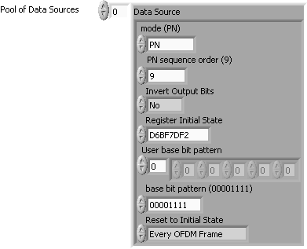

Figure 5: Front panel for configuring the Data Source Pool (Step 1).

- Configure Modulator Source Pool: Click on the “Modulators”, control to configure an Array of Modulator Sources. By default four Modulators sources are pre-configured. The default modulators can be edited from the initialization VI. Each modulator Source can be configured to the following two types of Modulation schemes.

  - PSK (default)
  - QAM

- M-PSK: This allows the user to select one of the following PSK modulation formats, 2-PSK, 4-PSK, 8-PSK, 16-PSK, 32-PSK, 64-PSK, 128-PSK and 256-PSK. The selection is applicable if the type of modulation selected is PSK.

- M-QAM: This allows the user to select one of the following QAM modulation formats, 4-QAM, 16-QAM, 64-QAM and 256-QAM. The selection is applicable if the type of modulation selected is QAM.

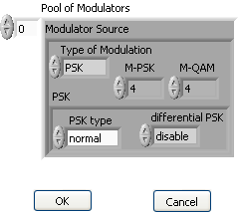

Figure 6: Front panel for configuring the Modulator Source Pool (Step 2).

- Configure OFDM Symbol: Click on the “OFDM Symbol” control to open the examine/configure OFDM symbol process. This allows the user to associate different data sources and modulators to the sub carriers. Actual data encoded is not generated until the waveform is generated in Step 6. Not all carriers have to be used. A sub carrier that is switched off has a constant zero amplitude and is ignored by data sources and modulators.

Symbol Pool: Click on the Symbol pool control to display all the OFDM symbols that have been configured. These prototypes are used to build the OFDM Frame in Step 4.

Current OFDM Symbol: Displays the name of the OFDM symbol prototype that user is currently editing. User can also assign a new name.
# Of Sub Carriers: The control sets the FFT length in samples, i.e. the number of available sub Carriers in the OFDM Symbols.
Length of Cyclic Prefix: Cyclic prefix (in samples) can be set for the OFDM symbol. This acts as a guard interval which is inserted at the beginning of every OFDM symbol and contains the selected number of samples that are copied from the end of the symbol’s useful part. The duration of this guard interval must be long enough for all echoes that stem from previously transmitted OFDM symbols to fade away. Therefore, in an OFDM system design, cyclic prefix length is given by the longest difference in traveling time to be expected between two multipath propagation paths. Single sub carrier/Range of Sub Carrier: The control allows the settings to be applied to a single sub carrier or a range of sub carriers. The control defines the edit range.
Data Source/Modulator Source: Configured Data Sources and Modulator Sources from Step 2 and 3 can be selected, which is assigned to the sub carriers within the edit range. Details of the data source and modulator source selected are displayed as read-only indicators.
Sub Carrier: The check box allows the user to enable/disable the sub carriers within the edit range.
Single sub carrier/Range of Sub Carrier: The control allows the settings to be applied to a single sub carrier or a range of sub carriers. The control defines the edit range.
APPLY: Click APPLY to carry out the selected modifications in the currently edited OFDM symbol.

Symbol Table: This is a sub carrier table which contains detailed information on how all sub carriers in the currently edited OFDM symbol are configured. User can scroll through the table and verify the data sources and modulators associated with the carriers. The table also displays the state of the sub carriers.

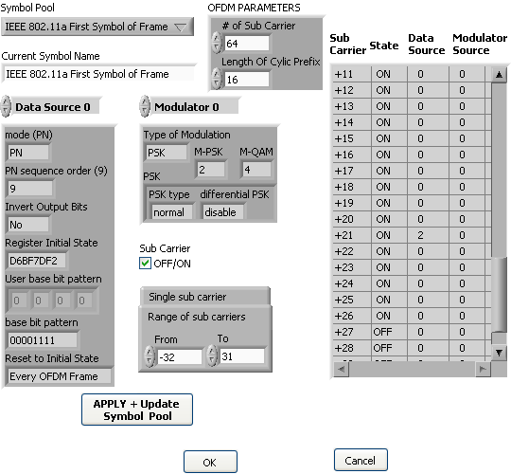

Figure 7: Front panel for configuring the OFDM Symbol (Step 3).

- Configure OFDM Frame: Click on the “OFDM Frame” control to configure the OFDM Frame that is to be generated. A Frame is defined as a certain time span that is filled with OFDM Symbols. Frame is the highest layer of organization within the time structure of the signal to generate.
Symbol Pool: The Symbol pool control displays all the OFDM symbols that have been configured. The user can select any OFDM Symbol from the existing pool.
Add: Click the “Add” control to include the selected OFDM symbol in the Frame. The OFDM symbol is added after the already occupied OFDM symbols or at the selected row.

Delete: The control “Delete” removes the last added OFDM symbol in the OFDM Frame or the symbol at the selected row. If the OFDM Frame is empty, the control takes no action.
# Of Symbols: The control allows the user to repeat as many times the selected OFDM symbol. For example the third OFDM symbol in the figure below is repeated 4 times (IEEE 802.11a with QPSK, PN(9)).
Total Symbols: This allows the user to see how many symbols have been added in the Frame.

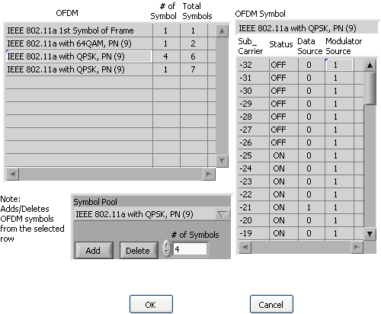

Figure 8: Front panel for configuring the OFDM Frame (Step 4).

- Configure Pulse Shaping: Click on the “Pulse Shaping” control to configure the parameters for pulse shaping. The configuration vi also displays the filter coefficients for the selected parameters. The parameters that are available for configuring pulse shaping are explained below:
Samples per Symbol: Specifies the number of desired samples per symbol for the pulse shaping filter. Specify an even number >2.
TX Filter: Specifies the class of filter to generate. Following three options are available:
- None
- Raised Cosine
- Root Raised Cosine
Alpha: This is a filter parameter which specifies the rolloff for raised cosine and square root raised cosine filters. This input is ignored when the TX filter is set to none.
Filter Length: Specifies the desired length of the pulse shaping filter, measured in symbols. The length of the matched filter can vary according to filter type and modulation type. Valid values are > 1.
Symbol rate: specifies the desired symbol rate in units of Hz.

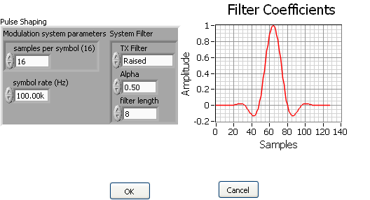

Figure 9: Front panel for configuring the pulse shaping parameters (Step 5).

- Write Configuration To File: Click on the “Write Configuration To File” control to store the current configuration in an .ofm file (Step 6). Same can be read back by performing Step 0.

- Generate Waveform: Click on the “Generate Waveform” control to generate and transmit the OFDM Frame configured in STEP 4 and the pulse shaping incorporated in Step 5. The waveform may be generated with the following three options:

Phase Continuous Waveform: This generates a phase-continuous OFDM modulated signal which may be used with the arbitrary waveform generator.
Store Waveform To a Datalog File: Click on the “Store Waveform to a Datalog File” control to store the generated waveform in a Datalog file.
Store Waveform + Configuration To Files: Click on the “Store Waveform + Configuration To Files” to store both the waveform and the configuration variant. By default the configuration variant is always stored in the waveform Datalog file as an attribute. Storing the configuration variant in a separate file facilitates storage without the waveform being stored.

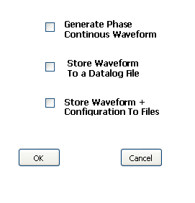
Figure 10: Front panel for configuring the waveform generation (Step 7).

Outputs
- Status: This is a cluster of indicators to display the current configuration status. It contains following information:

  - Sub Carrier: Displays the total number of sub carriers in the current OFDM Symbol
  - Cyclic Prefix: Displays the number of Cyclic Prefix in samples
  - Pool Size (Data source): Displays the number of Data sources that have been configured.
  - Pool Size (Modulator source): Displays the number of modulator sources that have been configured.
  - OFDM Symbol? The display is set to TRUE, if at lease one OFDM symbol has been configured.
  - OFDM Frame? The display is set to TRUE if at lease one OFDM symbol has been included in the OFDM Frame.
  - Transmit Filter: This displays the filter selected in Step 5 for pulse shaping.

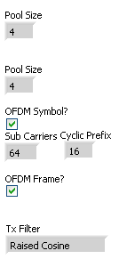
Figure 10: Front panel status Indicators.

- Output Complex Waveform: The complex waveform generated for the OFDM Frame configured in Step 4.

- FFT Spectrum. This is the Transmit FFT spectrum.

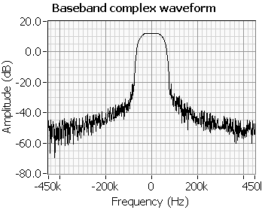

Figure 11: Spectrum of transmitted baseband complex waveform.

Main Vi’s Inputs and Outputs
- Mod_OFDM_Initialization.vi: The VI initializes the configuration variant and sets the default values of the attribute like, pool of data sources, pool of modulator sources and pulse shaping parameters. These default values can be edited by changing the default values of the input controls.

- Mod_OFDM_Check_Status.vi: This VI retrieves the configuration variant and determines their values in order to display the current configuration status.

- Mod_OFDM_Read_Configuration_From_File.vi: Allows the user to load a pre-configured saved file. The VI loads all the settings up to the Pulse shaping parameters.

    - Note: The entire current configuration is lost if the VI is executed. The current settings are over written by the file which is read by the VI.

- Mod_OFDM_Examine_Configure_Data_Sources.vi: The VI performs following three functions:

  - Examine pool of data sources that have been configured.

  - Add/Edit the current pool of Data sources. By default four Data sources are pre-configured.

  - To store the current pool of data sources in the configuration

- Mod_OFDM_Examine_Configure_Modulator_Sources.vi: The VI performs following three functions:

  - Examine pool of Modulator sources that have been configured.

  - Add/Edit the current pool of Modulator sources. By default four Modulators are pre-configured.

  - To store the current pool of modulators in the configuration

- Mod_OFDM_Examine_Configure_Data_Sources.vi: The VI performs following three functions:

  - Examine pool of data sources that have been configured.

  - Add/Edit the current pool of Data sources. By default four Data sources are pre-configured.

  - To store the current pool of data sources in the configuration

- Mod_OFDM_Examine_Configure_OFDM_Symbol.vi: The VI allows the user to examine/configure the OFDM symbol structure. The user can define prototypes of the OFDM symbols that are required to be generated or/and stored. These prototypes are kept in a pool and can be used to construct OFDM Frames.

- Mod_OFDM_Examine_Configure_OFDM_Frame.vi: The VI allows the user to examine/configure the OFDM frame that is to be generated. A Frame is defined as a certain time span that is filled with OFDM Symbols. Frame is the highest layer of organization within the time structure of the signal to generate.

- Mod_OFDM_Examine_Configure_Pulse_Shaping_Parameters.vi: The VI allows the user to examine/configure the pulse shaping parameters that are used for upsampling during waveform generation. Following parameters are configured:

    - The Samples per Symbol: Specifies the number of desired samples per symbol for the pulse shaping filter. Specify an even number >2.

    - Tx Filter: Specifies the class of filter to generate. Following three options are available:

      - None
      - Raised Cosine
      - Root Raised Cosine

    - Alpha: This is a filter parameter which specifies the rolloff for raised cosine and square root raised cosine filters. This input is ignored when the TX filter is set to none.

    - Filter Length: Specifies the desired length of the pulse shaping filter, measured in symbols. The length of the matched filter can vary according to filter type and modulation type. Valid values are > 1.

    - Symbol rate: specifies the desired symbol rate in units of Hz.

- Mod_OFDM_Write_Configuration_To_File.vi: Stores the current configuration in an .ofm file which can be read back by the "Mod_OFDM_Read_Configuration_from_File" VI

- Mod_OFDM_Examine_Configure_Waveform_Generation.vi: This is a dialog VI which allows user to select from the following three options:

    - Phase Continuous Waveform: This generates a phase-continuous OFDM modulated signal which may be used with the arbitrary waveform generator.

    - Store Waveform To a Datalog File: Click on the "Store Waveform to File" control to store the generated waveform in a Datalog file

    - Store Waveform + Configuration to Files: Click on the "Store Waveform + Configuration to Files" control to store the generated waveform in a Datalog file and the configuration in an .ofm file.

- Mod_OFDM_Complex_Symbols_Generation.vi: The VI generates the baseband complex symbols for the configured OFDM frame. Following five functions are performed by this VI.

    - Converts Variant: Recovers the configuration settings from the variant into a Array of clusters. The size of the array is the number of OFDM Symbols in the frame. Each cluster contains the configuration settings.

    - Generates Bits: For each OFDM Symbol in the Frame, bits are generated depending on the configuration settings.

    - Performs Complex Mapping: Complex mapping of the bits generated are performed based on the modulation scheme selected.

    - Applies IFFT: Block IFFT is performed on the complex signal.

      - Note: The common way to implement the inverse Fourier transform is by an inverse Fast Fourier Transform (IFFT). If, for example, a 64-point IFFT is used, the coefficients 0 to +31 are mapped to the same numbered IFFT inputs, while the coefficients -32 to -1 are copied into IFFT inputs +32 to +63. The mapping is illustrated in the Figure below.

    - Cyclic prefix is added: After performing an IFFT, the output is cyclically extended to the desired length.

- Mod_OFDM_Complex_Waveform_Generation.vi: The VI generates the baseband complex waveform by applying pulse shaping and symbols for the configured OFDM frame. Following five functions are performed by this VI.

    - Converts Variant: Recovers the configuration settings from the variant into an Array of clusters. The size of the array is the number of OFDM Symbols in the frame. Each cluster contains the configuration settings.

    - Generates Bits: For each OFDM Symbol in the Frame, bits are generated depending on the configuration settings.

    - Performs Complex Mapping: Complex mapping of the bits generated are performed based on the modulation scheme selected.

